College Recruiting Ad Strategy Using Google Analytics

Team 2:

BB, NK, RS, Jennifer Mead

Table of Contents

Introduction 2

Summary of past campaigns 2

What were the time frames for each marketing campaign? How much was spent on each campaign? 2

What was the effectiveness of previous campaigns? 3

Plan for next year 3

Identify the key aspects of a United States campaign for next year 3

a) In which geographic region would you advertise? Which states? Why? 3

b) What keywords would you use? Why? 5

c) Which days of the week and what time of day would you advertise? Why? 5

Cost for advertising campaigns 7

Identify the costs for your advertising campaigns 7

Measuring performance 8

How would you measure performance of your decisions after implementation? 8

Additional data and next steps 9

What other factors or considerations are important? 9

What other data would help in developing an Internet advertising strategy, if you could collect it? 10

# Introduction

The Whitman School of Management ran a recruiting campaign in February 2011, where they used ads in Google and in the Delta Airlines flight magazine. We have analyzed the results of these campaigns and have used this analysis to inform a strategy for the next recruiting campaign. The goal of the campaigns is to recruit the best students in the US, where “best” is defined by GMAT scores, and where the budget is $100,000.

In our campaign for the next school year, we will focus on recruiting students with the highest GMAT in the selected regions. After analyzing the success of this campaign, we will plan a subsequent campaign. It is necessary to have a method for measuring the performance of the campaign, because without a measure we cannot make any conclusions or plan the next campaign. [Note that for this assignment, the data we were given were real…but an add subset of Google Analytics data that we did not control.]

# Summary of past campaigns

## What were the time frames for each marketing campaign? How much was spent on each campaign?

The time frames and cost per each campaign are presented below. The most expensive campaign was iMBA while Delta was the least expensive. Campaign dates varied and covered 2011-2013 period.

|  |  |  |  |  |  |  |  |  |  |
| --- | --- | --- | --- | --- | --- | --- | --- | --- | --- |
| Name | From Date | To Date | Number of days | Cost | Sessions | Cost Per Day | Session Per Day | Bounce Rate | Page Sessions |
| Whitman.syr.edu | 2/26/11 | 8/26/11 | 182 | $37,851.36 | 7313 | $207.97 | 40.18 | 78.20% | 1.84 |
| MBA Marketing – full-time | 10/26/12 | 7/1/13 | 249 | $72,709.90 | 4286 | $292.01 | 17.21 | 82.50% | 1.27 |
| MBA Marketing -- iMBA | 2/2/12 | 10/26/12 | 268 | $80,663.24 | 3170 | $300.98 | 11.83 | 89.50% | 1.13 |
| Delta | 9/22/13 | 11/7/13 | 47 | $10,000.00 | 65 | $212.77 | 1.38 | 30.77% | 3.2 |

## What was the effectiveness of previous campaigns?

|  |  |  |  |  |  |
| --- | --- | --- | --- | --- | --- |
| Name | Effectiveness Total | Effectiveness Cost | Effectiveness Sessions | Effectiveness Bounce | Effectiveness Page |
| Whitman.syr.edu | 69.58 | 69.10 | 100.00 | 21.80 | 57.50 |
| MBA Marketing – full-time | 56.15 | 97.02 | 42.84 | 17.50 | 39.69 |
| MBA Marketing -- iMBA | 50.78 | 100.00 | 29.44 | 10.50 | 35.31 |
| Delta | 52.92 | 70.69 | 3.44 | 69.23 | 100.00 |

Based on the given results, the most effective campaign is Whitman.syr.edu.

We calculated effectiveness by implementing the following formula:

Effectiveness = 1/3 weighted Cost + 1/3 weighted Awareness + 1/3 weighted Interest

* + Cost - Cost Per Day
  + Awareness - Sessions Per Day
  + Interest - Bounce Rate and Page Sessions

Calculations for Weighted Cost per Day, Weighted Session per Day, and Weighted Page Sessions were done by calculating the proportion of the value from the max of all values for that variable. For example:

* The calculation of effectiveness Cost for Whitman.syr.edu is

(100*207.97) / MAX (207.97, 292.01, 300.98, 212.77) = 69.10

* Effectiveness for Bounce was calculated by subtracting the value of Bounce per hundred from the 100. For example, calculation of effectiveness Bounce for the Whitman.syr.edu is 100-78.20=21.80

# **Plan for next year**

## Identify the key aspects of a United States campaign for next year

### In which geographic region would you advertise? Which states? Why?

For each online campaign, we took the ten states with the highest number of sessions from Geo section/Google Analytics. Final rank was calculated by equally weighting Bounce Rate, Pages per Session, and Average Session duration rankings. If the Final Rank was below 7 (<70th percentile which was selected by the team) then a specific region was “Campaign eligible”. Using this method, we identified New York, Texas, New Jersey, Virginia, Florida, and North Carolina as Target States. See the calculations and ranking process below. The method allowed to narrow down the list of states which historically didn’t demonstrate a strong interest measured by three metrics discussed above when compared to other regions. The results of ranking process were intuitive to the team – California was a subject to exclusion as it is highly unlikely students from that specific state will be willing to relocate across the country to attend a full time program in a snowy NY. The state also is home to Berkeley and Stanford universities which offer MBA degrees and are highly rated.

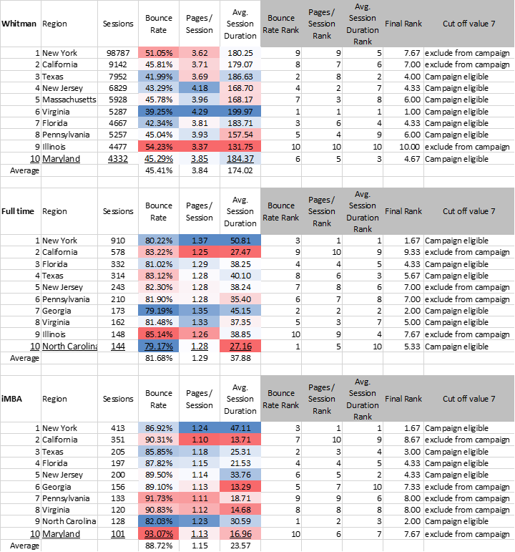

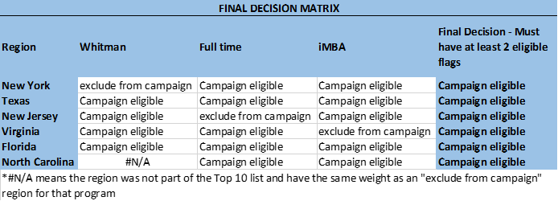

### What keywords would you use? Why?

We looked at the top keywords for the three online campaigns, and chose keywords that were related to high GMAT scores and good business schools. We should not advertise for “mba without gmat” because our goal is to get students with the highest GMAT score. We will continue to update keyword lists throughout the campaign as we get new data, but to start we will focus on the following:

* mba online
* good gmat
* syracuse mba
* top business school
* incorporates practical experience
* top mba
* best online mba

### Which days of the week and what time of day would you advertise? Why?

Based on the data below, we would advertise every day and hour, but place more ads on Tuesdays and Saturdays and between 5pm and 12 am. You can see the hour of the day the bounce rate is the lowest during that time frame and the number of sessions and new sessions are the highest concentration in that time period.

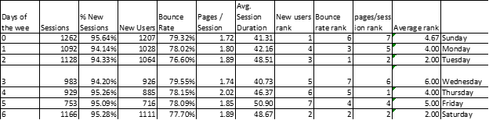

In this chart of activity by hour, the green cells show the best values and the red cells show the worst values. Notice that some metrics are higher in the morning (ex: Average session duration) and some are higher in the evening (ex: number of session). This is part of the reason why we will advertise throughout the day, but focus the most spending on certain time periods. For the time of the day we looked at the number of sessions and new users as a gauge to when to advertise during the day as a way to further find our peak area of activity for the campaign.

|  |  |  |  |  |  |  |
| --- | --- | --- | --- | --- | --- | --- |
| Hour | Sessions | % New Sessions | New Users | Bounce Rate | Pages / Session | Avg. Session Duration |
| 00 | 247 | 94.74% | 234 | 74.09% | 2.34 | 59.14 |
| 01 | 99 | 90.91% | 90 | 71.72% | 1.88 | 65.37 |
| 02 | 94 | 93.62% | 88 | 79.79% | 1.67 | 45.73 |
| 03 | 47 | 97.87% | 46 | 72.34% | 1.85 | 60.34 |
| 04 | 45 | 95.56% | 43 | 86.67% | 1.42 | 38.36 |
| 05 | 25 | 84.00% | 21 | 72.00% | 1.84 | 64.04 |
| 06 | 52 | 98.08% | 51 | 78.85% | 1.87 | 60.90 |
| 07 | 68 | 94.12% | 64 | 76.47% | 1.90 | 45.26 |
| 08 | 105 | 93.33% | 98 | 79.05% | 1.73 | 54.39 |
| 09 | 105 | 91.43% | 96 | 75.24% | 1.91 | 25.77 |
| 10 | 138 | 90.58% | 125 | 80.43% | 1.91 | 49.07 |
| 11 | 152 | 95.39% | 145 | 78.95% | 1.89 | 51.40 |
| 12 | 134 | 93.28% | 125 | 83.58% | 1.67 | 30.84 |
| 13 | 163 | 90.80% | 148 | 81.60% | 1.79 | 29.34 |
| 14 | 141 | 95.74% | 135 | 75.18% | 1.76 | 42.06 |
| 15 | 158 | 92.41% | 146 | 79.11% | 1.61 | 41.06 |
| 16 | 164 | 95.73% | 157 | 74.39% | 1.92 | 35.04 |
| 17 | 792 | 96.09% | 761 | 78.54% | 1.70 | 43.24 |
| 18 | 754 | 95.09% | 717 | 79.18% | 1.68 | 41.55 |
| 19 | 725 | 95.31% | 691 | 79.17% | 1.64 | 33.49 |
| 20 | 802 | 95.51% | 766 | 79.18% | 1.79 | 50.14 |
| 21 | 817 | 94.98% | 776 | 79.44% | 2.00 | 53.75 |
| 22 | 808 | 95.30% | 770 | 77.60% | 2.07 | 48.45 |
| 23 | 678 | 94.99% | 644 | 75.37% | 1.89 | 44.39 |
| Total | 7313 | 94.86% | 6937 | 78.20% | 1.84 | 45.27 |

# **Cost for advertising campaigns**

## Identify the costs for your advertising campaigns

* By region
* By degree program

We are going to advertise for all three programs. We’ve developed a budget based on the data that we have, but in order to confirm (or disprove) the conclusions of our analysis, we are going to start the campaign by running an A/B test (a common feature available through Google Analytics) of the Target States below against all of the other states. We will run this for two months. We expect this test to cost $10,000. Based on the results of those tests, we will then allocate the remainder of our budget. If the test goes as we expect, the remaining $90,000 budget would be allocated to the regions/states and degree programs as below.

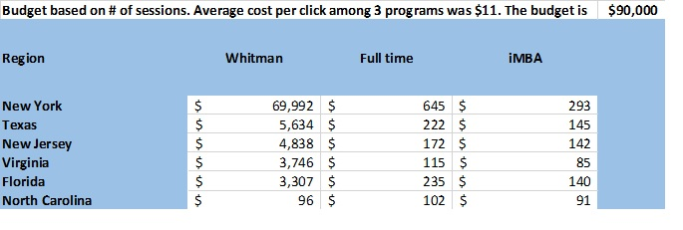

The budget for each state and program is allocated according to the historical number of sessions for each Target state selected in the analysis on page 4 using the weighted approach. The summary of sessions is below.



Also note because that our students are diverse, we should advertise in a variety of places: Google, Bing, Yahoo, Facebook, LinkedIn, Twitter, and others. Our analysis does not support focusing on any one of these in exclusion of the others.

o The most popular operating system is Windows.

o Facebook is the social network from which we get the most traffic.

o Google is the most common search engine.

o Users are more likely to use a desktop computer than mobile device.

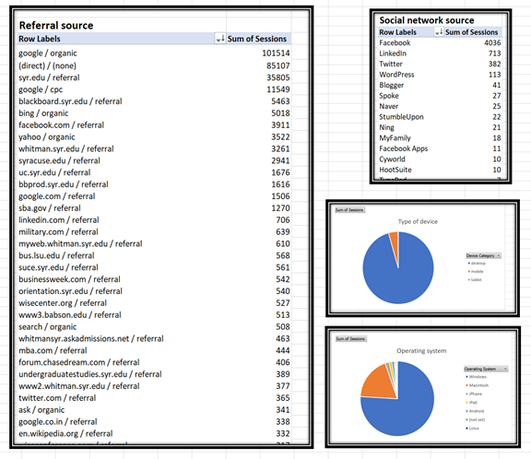

# **Measuring performance**

## How would you measure performance of your decisions after implementation?

For consistency, we would continue to use the same calculations for ranking that we’ve used in this analysis-- a combination of cost, number of users, new users, pages per session, session duration.

In addition, we would use conversions data for campaigns. For a recruiting campaign, a conversion tracks a user on a website through when they click “Apply”. It needs to be set up in order for Google Analytics to track it, but it is a standard feature. See the columns on the right in the image below.

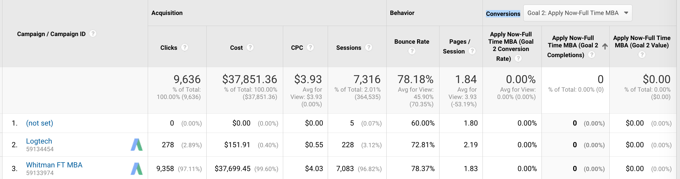

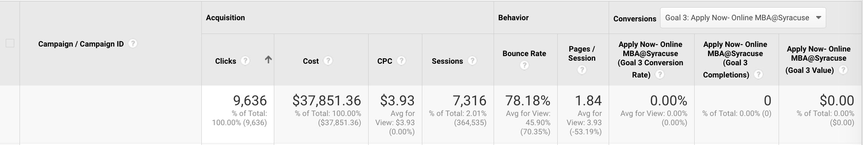

Additionally, we would track behavior flow (picture below) to see how our campaign influences prospective users.

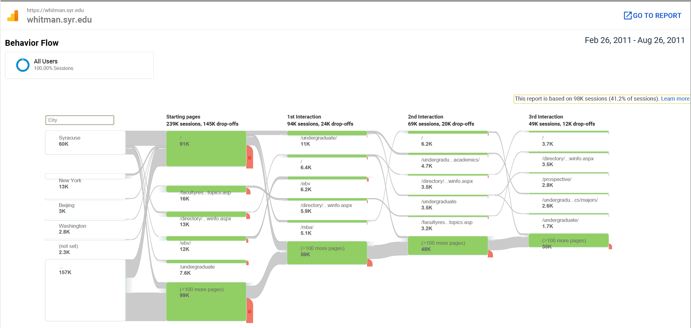

# **Additional data and next steps**

Online advertising campaigns are being improved by constant revision, adding in new data, evaluating it, and modifying the campaign on an ongoing basis. The following information would help us continue to improve the campaign.

## What other factors or considerations are important?

* We need to gather more information about students with highest GMAT scores to target them. It is not enough to know only their location; we need to learn more what can we offer to best users, that top MBA programs do not have.
* It should be noted that we would be significantly more confident in our analysis if we knew the GMAT scores of the current students in the three programs and the relative profit of the three programs. If the i-MBA program makes the most money (perhaps it is more cost-effective to run an online program) and that program has so far attracted students with higher scores, we’d put more money there.

## What other data would help in developing an Internet advertising strategy, if you could collect it?

* If we have a list of priorities for students with the highest GMAT. If Syracuse MBA program offers some of those items, we would add those keywords to our campaign. For example, class day and time, professor credentials, success story, etc.
* If we learn about information source of those students, we can use it for our campaign. For example, if those students do not use Facebook, we would remove it from our campaign. If number one source is LinkedIn, we will advertise using LinkedIn.
* Ideally, we need to know if a candidate from a specific IP address applied for an MBA program online within six months. An increase in average GMAT score compare for those applications when compared to the average Whitman 530 GMAT score for US students would demonstrate the success of the new campaign.
* We would like to pull GMAT scores per state and compare that to the google analytics data and that would help further narrow the areas to advertise
* On the application, we will get the applicant’s GMAT score. We should also ask where they heard about the program (Facebook, LinkedIn, Google search, etc.) so that in the future we can match the high scores with the way they found us. Though it may not be fully accurate (maybe they heard of us from more than one place, maybe they can’t remember), this approach does have the advantage that we know we are matching the right score with the source, something that Google Analytics cannot offer us.
* We should investigate the costs for advertising in the search results for our top competitors that tend to attract students with high GMAT scores. These are the students we want; if they are aware of what we offer we may be able to win them over on price and other qualities our competitors lack.